**Writing Training**

**Lesson10_structure**

前9课中，我们详细地介绍了有关于一篇英文议论文的方方面面，相信同学们已经有了整体的了解。然而，在四六级、考研英语、托福、雅思等语言考试中，作文的部分并非是严格按照“提出总论点——论证总论点——收尾”的格式进行的，而是有自己的行文规范与对应内容，因此在最后一节课中，我们来熟悉一下语言考试中的作文规范，以考研英语为例。

essay在语言考试中往往指一种短议论文。这种文章在四六级、考研等国内考试中应严格写成三段，而在托福、雅思、GRE等考试中则需四至六段。考研论说文一般有2~3点提纲，每点提纲写成一段，顺序不可打乱。通常，第一段3句，第二段5句，第三段4句。

根据最新考研大纲，论说文具有四大要素：描述、寓意、分析、评论。第一段一般是图画或图表描述，不宜发表太多议论；第二段一般是意义阐释段，分析图画或图表的含义；第三段一般是建议措施或者结论归纳段，即对图文反映的问题发表自己的议论或者看法。

整体的框架结构大致如下：

（一）introduction：引言/起始段，图画描述段，3句。

* General description：总体描述，1句。
* Details：挖掘细节词、联结成句，1-2。
* Caption：文字说明，1句。

（二）body：主体/拓展段，意义阐释段，5句

* Topic sentence：主题句，即symbolic meanings，1句。
* Argument：论证，3句

1. 五大角度：backgroud,facts,others’opinion,reasons,consequence
2. 六种论证方式：casue and effect, classification, definition and explanation, statistics and facts, exemplification, compare and contrast.
3. 联系实际

* Summary：小结，1句，概括论证，总结本段

（三）Conclusion：结论段，建议措施段，4句

* Concluding sentence：结论句，1句。
* Suggestions：两点建议或两句评论，2句
* 包装结尾，展望未来：1句

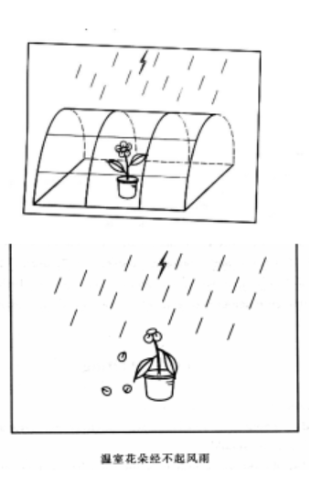下附一篇真题与范文供大家参考：

【题目】Direction:

Study the following set of drawings carefully and write an essay in which you should

1. describe the set of drawings,interpret its meaning, and
2. Point out its implications in our life.

You should write about 200 words neatly on the ANSWER SHEET.

The set of drawings above vividly depicts the destiny of a flower in different circumstances. As is shown in the first cartoon, the flower is placed in a comfortable greenhouse that shelters it from the threatening lightening and storm. With proper temperature, moisture and fertilizer, the flower is growing in full bloom. On the contrary, when removed from the greenhouse and exposed to the driving rain, the flower soon fades and withers, with the petals cast about on the grounds.

　　To begin with, the purpose of the drawings is to show us that the flower growing in the green house cannot withstand the test of the storm, yet the symbolic meanings subtly conveyed should be taken more seriously. The delicate flower is naturally associated with young people, to be specific, the only children in our current society; the greenhouse epitomizes parents doting care and abundant material supplies that can shield the children from the storms, or the harsh reality. Once the young people begin to seek independence and accept challenges from the real world, they are found too spoiled to be strong enough in the face of difficulties.

Accordingly, it is vital for us to derive positive implications from these thought-provoking drawings. On the one hand, we can frequently use them to enlighten the youth to be more independent in life. On the other hand, parents should be sensible enough to give their children more freedom to deal with troubles and problems. Only by undergoing more challenges and toils in adversity can young people cultivate strong personality and ability, and only in this way can they become winners in this competitive world.

以上内容节选自《2022新东方考研英语高分写作》王江涛编著，2021年01月第一版p110-p111，节选时有删改。